Game Desing Document

**Core gameplay:**

The player will first be introduced to the initial setting of the game. It is a world in which the King’s crown was suspiciously stolen by a rogue mage. Traces of a map to find the whereabouts of the rouge mage have been scattered around the world and the player has been tasked by the king to retrieve his precious crown.

The player will then start with an initial tutorial style level with which the player will be introduced to the mechanics of the bow and arrow. The player will be able to aim and shoot at enemies. The levels will be in the form of a platform-style game where they will face obstacles as well as enemies to reach the end of each level. At the end of every level, the player will unlock a new piece of the map. The player also has the opportunity with some levels to unlock a new ability – left by the rouge mage to find – which will help them to traverse as well as combat in the levels that follow.

In every level the player will have checkpoints – this will be used when a player dies through combat or traversal as these will be used as respawn points.

Within each level, there will also be some hidden hearts that the player can use to restore their health – which could be lowered through combat with enemies within the level.

At the end of the game, once the player has unlocked all parts of the map, the player will face what they think the final boss is – the rouge mage. The player will have access to all powers that they have unlocked throughout the game. The player will then return the crown to the king through a cut scene. However, an unexpected event happens. The king ends up being evil and wears the crown to gain special powers. This will be the very last battle that the player must face, only once the player has defeated the evil king, will peace be restored in the world.

**Level design: What type of levels do we want to include**

| Level | Description | Inspiration |
| --- | --- | --- |
| 1 | The player starts in a calm meadow-type environment with few obstacles and enemies. This will function as the game tutorial introducing the player to the game's main features. At the end of this level, the player will unlock the first additional power, a fire attack. |  |
| 2 | A dense forest with many enemies. Since this is only the second level, the enemies aren’t difficult to defeat and the environment is relatively easy to traverse. Here the player will be able to explore the new fire attack ability. The player will unlock the next ability at the end of this level which will allow them to temporarily freeze enemies as well as freeze rivers. This will allow them to traverse the following environments much easier. |  |
| 3 | The next environment is a dark forest area. Here the player will be tested on their ability to traverse the environment through multiple platforms and obstacles. There will be less emphasis on combat since the goal is to allow the player to explore the new ability, which is to freeze items. |  |
| 4 | The second-to-last level will take place in a lava field. The player will face many new enemies which will challenge them and allow them to make use of all the new abilities that they have unlocked in the previous levels. |  |
| 5 | The player finally enters the dark castle where the rouge mage hides. The player faces the most enemies of all the levels. The player will unlock the final spell which will allow them to manipulate gravity yellowing them to smash players into the ground. |  |
| Boss Level | The player then returns the crown to the king. Little did they know that the crown has a secret ability that gives the king all of the powers that the rouge mage has given to the player. The player will now have to face their final battle in which they have to defeat the evil king. The environment will be similar to the starting level, but the player will again be restricted to a small arena |  |

**Powers that the mage can unlock – potentially be a table format**

1. Bow & arrow: This will be the initial combat that the player will use starting up. It will provide a ranged combat with which the player will be able to kill enemies.
2. Fire is the first power that the player unlocks. It is a form of ranged combat in which each shot causes more damage to enemies, but there is a cool-off time between shots.

*Therefore, the player will need to decide on the playstyle they prefer: causing more damage per shot but having to wait longer for the next shot or continuously shooting the enemies but causing less damage per shot.*

1. Ice/freezing: This is a multifunctional ability, though the player will need to discover the second ability themselves. The game will show the player that the freezing power allows them to traverse the environment more easily by freezing rivers. The hidden ability is that the player can freeze enemies for a short period, giving the player some additional time to defeat enemies.
2. Levitation: The player will be able to levitate obstacles that the player would come across in certain levels. The spell will levitate the item for a few seconds allowing the player to overcome the obstacle.

**Combat – enemies that the player will have to fight**

The starting level 1&2 will have enemies that just partake in close combat.

Inspiration:

 

In the following levels, there will be more mystical creatures like goblins, eye monsters, and a skeleton. These will all have a ranged form of combat.

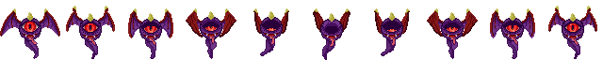



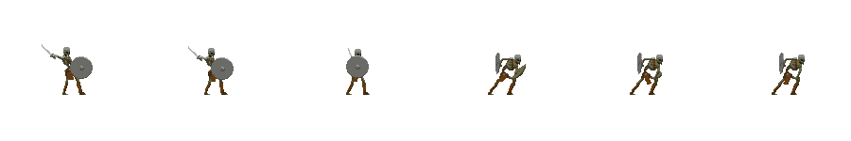

**Endgame**

Once the player has successfully gathered all of the pieces of the map, then they will be able to face what they think to be the final boss – the rouge mage. This will take place within the castle which the player will first have to traverse through. Once the player enters the final room, the player will be locked inside the room and have limited space. This is the arena where the player will face the rouge mage. The rouge mage will be able to move around the environment and will have much larger health than the normal enemies. The player will be able to make use of all the powers that they have unlocked throughout the gameplay. Additional health will also spawn as needed throughout the battle.

Once the player has defeated the rouge mage, a cut scene will play where the character returns the king’s crown. However, there is a turn of events where the crown is cursed and gives the king special powers. Now the king is trying to destroy the world and the player will have to defeat the final boss – the king. The set-up will be similar to the previous boss battle, though the king will be even more difficult to fight. Once they have successfully defeated the king the player finishes the game.

Inspiration:

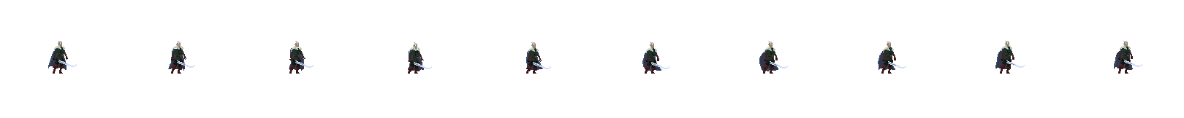

**Character design**

Idle

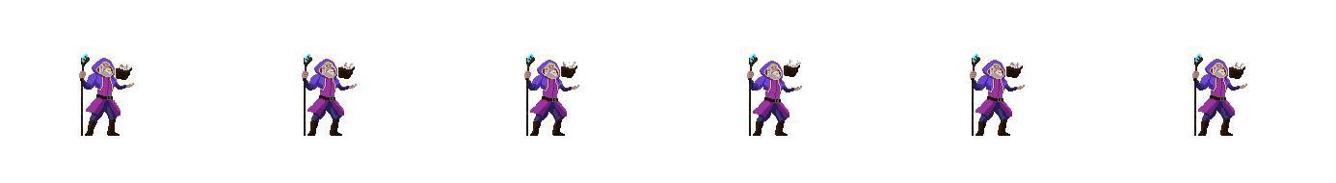

Levitation spell

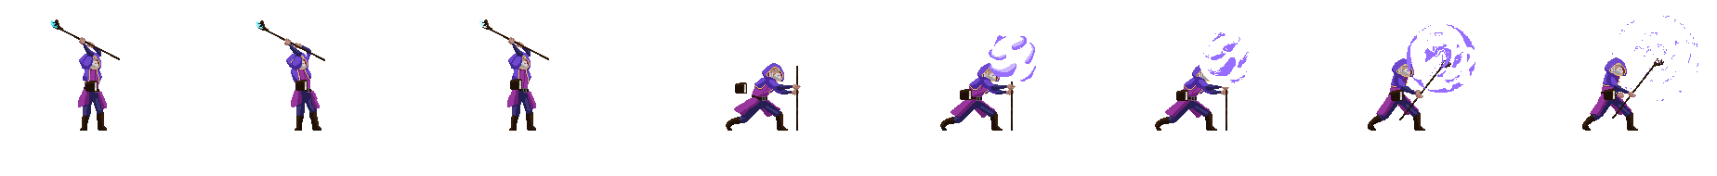

Fire attack

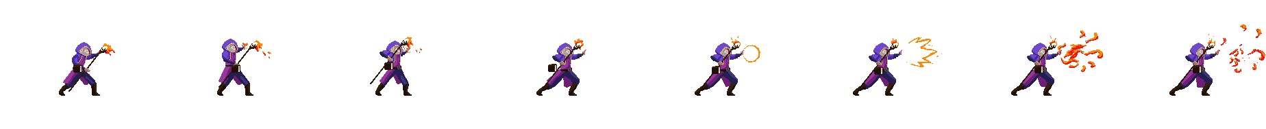

Ice attack  
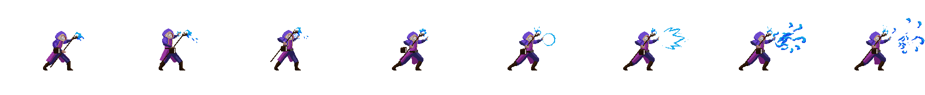

Bow and arrow

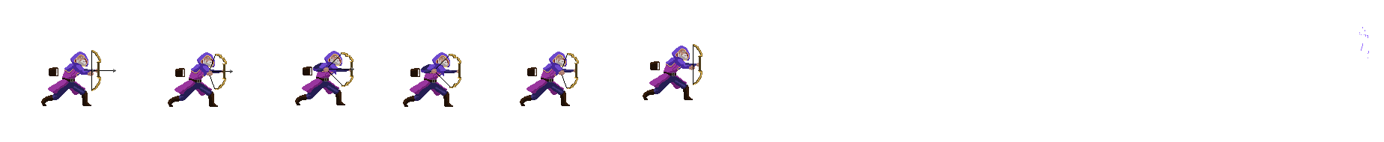

**Additional graphic design**

Health



Fragmented map – it will consist of titles from the following asset that will be arranged

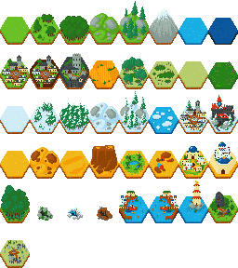

**Menu design – a very simple prototype**

*Start game*

*Levels*

*View map*

*Tutorial*

*Settings*

*Quit game*

**Glossary – key terms used within the game that might need clarification**

*Please use this as an indicator of what we need to mention, we could add in additional headings or remove some if we feel like we don’t need them. Also I used James’ examples to make this list*

Technical Design Document

**System design diagram – eg. MVC design**

**Explain all parts of the diagram**

**Game controls implementation**

*How user input works – mention the use of unity which includes most libraries and packages*

The player will mostly interact with the game through keyboard inputs, the basic A key for moving left in the world, and D for moving right in the world. The player can also jump through the space bar. For combat, the player will be able to use ranged weapons like the bow and arrow. The player will press the caps lock button to equip the different spells and will use the left click on the mouse to start shooting.

**Game AI**

*Here we would probably talk about the enemies that the player would face*

The enemies would have some state transition that they would go through which applies to all enemies within the levels. They will have the following states:

* Idle: they would be stationary and unaware of the player – this would be the starting state
* Patrolling: some enemies will start in this state if they are placed on a specific platform. They will walk back and forth on the platform until they transition to the next state.
* Chasing: when the player is close enough to the enemy, will the enemy start running towards the player to go to the next state.
* Attacking: the enemy will start attacking the player once they are close enough. They will start causing damage to the player’s health during this state.

**Data management**

*How are assets stored and how will player information be stored*

Information like the level progression needs to be stored on the computer so that if the player doesn’t finish and wants to continue another time, they can do so and start at the place they left it. This will be done through simple binary files that will contain the following critical information:

* Levels completed
* Current health of the player
* Time spent in-game

**Interface**

*What programming language will we use & functionality of the interface?*

The programming language that Unity uses is C# which is used for character behavior

**Iterative development - what will we do first etc.**

**Art assets – list all of the ones that will be used**

*\*Some assets might change as game development progresses*

| Type | Dimensions | Number | Version |
| --- | --- | --- | --- |
| Level 1 background - Meadow | 384x240 | 1 | 1 |
| Level 1 tileset | 480x176 | 10 | 1 |
| Level 2 background - Mystical forest | 384x240 | 1 | 1 |
| Level 2 tileset | 480x176 | 10 | 2 |
| Level 3 background - Dark forest | 384x240 | 1 | 1 |
| Level 3 tileset | 480x176 | 10 | 2 |
| Level 4 background - Lava field | 384x240 | 1 | 1 |
| Level 4 tileset | 320x288 | 5 | 1 |
| Level 5 background - Castle | 384x240 | 1 | 1 |
| Level 5 tileset | 304x224 | 17 | 1 |
| Boss background - Dungeon | 384x240 | 1 | 1 |
| Boss tileset | 304x224 | 17 | 1 |
| King character design | 64x120 | 2 | 1 |
| Mage character design | 64x120 | 1 | 4 |
| Floating eye | 36x36 | 10 | 2 |
| Slime | 36x36 | 8 | 2 |
| Mushroom | 36x36 | 11 | 1 |
| Goblin | 36x36 | 12 | 1 |
| Skeleton | 36x36 | 6 | 1 |
| Heart | 28x28 | 1 | 1 |

**Audio assets**

*\*Some assets might change as game development progresses*

| Type | Duration | Version |
| --- | --- | --- |
| Background music - Crystal ball | 60 seconds | 1 |
| Player running |  |  |
| Player Attack sound |  |  |
| Enemy attack sound |  |  |
| Boss attack sound |  |  |

**Glossary**

*Please use this as an indicator of what we need to mention, we could add additional headings or remove some if we feel like we don’t need them. Also, I used James’ examples to make this list*

assests

<https://phi9009.itch.io/mountain-peak-background-pack>

<https://sir-raitan.itch.io/a-mountain-and-forest-landscape>

<https://theconceptofchris.itch.io/moten-lava-32-x-32-tile-set>

<https://mevnieenn.itch.io/the-forest-cries>

<https://harbingersolution.itch.io/grassy-meadow-parallax-background>

<https://petricakegames.itch.io/castle-lilac-platformer-tileset>

<https://shakhanov.itch.io/black-bricks-tileset-32x32>

<https://pixeline-k.itch.io/pixel-art-creature-animal-porcupine>

<https://pixeline-k.itch.io/pixel-art-creature-animal-peacock-free>

<https://kale-game.itch.io/2d-pixel-art?download>

<https://oco.itch.io/medieval-fantasy-character-pack>

<https://luizmelo.itch.io/monsters-creatures-fantasy>

<https://trixelized.itch.io/starstring-fields>

<https://szadiart.itch.io/pixle-castle-2d>

<https://luizmelo.itch.io/wizard-pack>

<https://incolgames.itch.io/dungeon-platformer-tile-set-pixel-art>

<https://luizmelo.itch.io/fantasy-warrior>

<https://t-plus-lk.itch.io/animated-bow>

Sound

<https://kronbits.itch.io/freesfx>

<https://royaltyfreemusiclibrary.com/playlists/genre-fantasy>

### Track

**Crystal Ball** Main Mix

Code AXIS1206 ISRC QZ-264-23-49492

### Album

**Subtle Enchantment**

Code AXIS1206

### Composers

**James Harwood** PRO ASCAP IPI 479765682 Share 100

### Publisher

**Prolific 1 Publishing** PRO ASCAP IPI 561538053 Mechanical 100% Performance 100%

### Track

**On The Other Side** Full Mix

Code AXIS1114 ISRC QZ-264-23-54154

### Album

**Cinematics**

Code AXIS1114

### Composers

**Max DiCarlo** PRO ASCAP IPI 336358846 Share 100

### Publisher

**Prolific 1 Publishing** PRO ASCAP IPI 561538053 Mechanical 100% Performance 100%

dwarves.elves, ghouls, giants, ratmen, halflings, orcs,scelotens, sourcers,tritons, trolls, goblins, kobolds, homuncili, leperachauns, pixies, pygmies, skags,